Partnership Opportunities 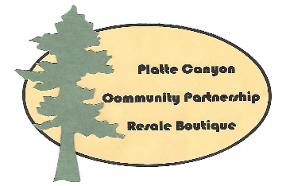 Between PCCP Resale Boutique & Community Non-Profits

our mission
As a community-based volunteer organization, Platte Canyon Community Partnership (PCCP) Resale Boutique supports non-profit organizations and local initiatives along the HWY 285 Corridor from Shawnee in Park County to Conifer in Jefferson County. Our purpose is to promote community partnerships through financial contributions –primarily through the Resale Boutique- and to utilize the expertise of volunteers.

Overview
Focus of beneficiary will be on children and families in need. Once a non-P\profit is selected as a beneficiary, a plan will be developed. Each non-profit is unique in terms of its purpose, goals, current programs, volunteer base, and financial needs. Therefore, the approach taken in partnering with PCCP Resale Boutique will be based on a common understanding of needs and resources.

A PCCP Resale Boutique Board Member will be a designated coordinator with each beneficiary non-profit for planning and coordinating volunteers and activities.

Percentage of Resale Boutique Profits in Designated Period of Time

- Participating non-profit can receive a percentage of profits from PCCP Resale Boutique to support specific projects or programs.
- Calendar selection can be from two weeks to two months
- Dates will not conflict with other non-profits
- Beneficiary non-profit will provide volunteers to the PCCP Resale Boutique that is equivalent to 4 hours per week according to plan worked out between coordinators
- Donated monies during other Resale Boutique activities and special events coordinated with the beneficiary will go to participating non-profit

Special Events/Activities at PCCP Resale Boutique Sponsored by Beneficiary

- Every viable opportunity will be evaluated
- Once event or activity is accepted, PCCP Resale Boutique and beneficiary will each have a representative to coordinate all action items with beneficiary non-profit taking the lead.
- Event will be placed on master calendar
- Based on size of event, the following will be addressed:
  - Physical space
  - Food/drink
  - Set-up and Tear-down
  - Volunteers
- Promotional information will be developed by beneficiary group; PCCP Resale Boutique will support through our networking and marketing opportunities

Communication/Promotions

- Each beneficiary non-profit will develop and produce all marketing and promotional materials
- PCCP Resale Boutique will provide space for promotional information, handouts, business cards
- PCCP Resale Boutique will help promote events via its email list, Facebook page, and website

Expected Results

Financial Benefits
- PCCP Resale Boutique will see an increase in sales that will, in turn, provide more opportunities to donate monies to local non-profits.
The benefiting non-profit will earn monies that will benefit specific projects and programs

Auxiliary Benefits
- Non-profits on ‘the mountain’ will gain more visibility concerning their roles in the community
- Special projects and events will be better supported
- The concept of ‘partnering’ among non-profits will be enhanced

