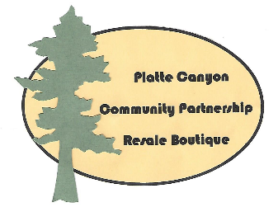
PARTNERSHIP APPLICATION
Non-profit information provided to
Platte Canyon Community Partnership (PCCP) Resale Boutique
Application Deadline: December 19, 2020
Return application (this form or online) to:
Resale Boutique in Bailey Plaza
or PO Box 904 Bailey 80421
or email pccpresale-boutique.org
[Sidebar Title]

Organization Information:
Legal Name of Organization:

Tax Exemption Status: EIN:

Mailing Address (and physical address if it is different and not confidential):

Telephone: Fax:

Email: Website:

Name: Executive Director

Name: Primary Contact

Phone: Email:
Please answer the following questions. Use additional pages if needed.
What is your mission statement?

Explain the specific program the PCCP Resale Boutique donations will support. How many people will be directly served or benefit from this program?

What need(s) will you be fulfilling in our mountain community as a result of our partnership?

Do you have a specific month or timeframe in mind that you would like to partner with the PCCP Resale Boutique?
The PCCP Resale Boutique asks that your organization provides the equivalent of eight (8) hours of donated time each week to the partnership. Please provide a preliminary plan for how you will schedule volunteers. Your PCCP liaison will help you finalize it if you become a beneficiary.

Are you considering any events or ways to publicize our partnership during our month of supporting each other?

What donor recognition would the PCCP Resale Boutique receive if our partnership is approved.

Signature of Applicant:________________________________________________
Title: _______________________________ Date:_________________________

