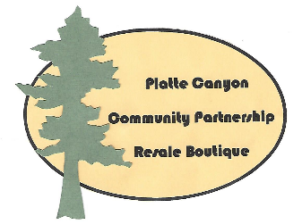
PARTNERSHIP APPLICATION
Non-profit information provided to
Platte Canyon Community Partnership (PCCP) Resale Boutique
Application Deadline: January 19, 2019
Return application (this form or typed) to:
Resale Boutique in Bailey or PO Box 904 Bailey
or email pccpresale-boutique.org
[Sidebar Title]

Legal Name of Organization:

Tax Exemption Status

EIN:
Mailing Address (and physical address if it is different and not confidential):

Phone: Fax:

Email: Website:

Name: Executive Director

Name of Primary Contact:

Phone: Email:

Organization Mission Statement:

Specific Programs/Projects the PCCP Resale Boutique Donations will support:

What needs will you be fulfilling in our mountain community as a result of our partnership?

Do you have a specific time-frame in mind during 2019 calendar year? (maximum two months)

The PCCP Resale Boutique asks that your organization provides approximately four (4) hours of donated time each week of the partnership. Do you have a plan at this time?

Are you considering any fund-railing events or projects that you would like the PCCP Resale Boutique to support?

What donor recognition would the PCCP Resale Boutique receive if our partnership is approved?

Signature of Applicant: _____________________________________ Title: _____________________________________Date:___________

